**Name: Shaunak Deshpande**

**Div.: TY-IC-C**

**Roll. No.: 39**

**GR no.: 11911180**

**Batch.: 2**

**LAB 3: - PID Tuning**

This exercise is based on the automatic control of a steam heater. The steam input to the heater is manipulated to maintain outlet temperature at setpoint. The user can introduce an unmeasured disturbance into the process to observe the impact on control.

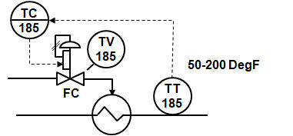

Step 1. In the Workspace tab, view the heater control and process simulation. Try manually tuning the PID in this example using manual tuning techniques:

* With the loop in Manual, change the manipulated parameter by a step to determine the process deadtime and time constant.
* Verify that the default control action is correct. Set the reset time equal to the deadtime plus the time constant.
* Set the proportional gain to a conservative value, for example, 0.1, and place the loop in automatic control.
* Change the setpoint and observe the control response. Gradually increase the proportional gain (leaving the reset at the value previously entered) to achieve the desired closed loop response.

Step 2. Try tuning the control loop for changes in disturbance inputs:

* Introduce a disturbance in the process and observe the control response. Try increasing the proportional gain by 50% and introduce a change in the disturbance. Was the control able to more quickly compensate for the disturbance?
* With the higher proportional gain, introduce a setpoint change. How did the increase in gain impact the response to a setpoint change?

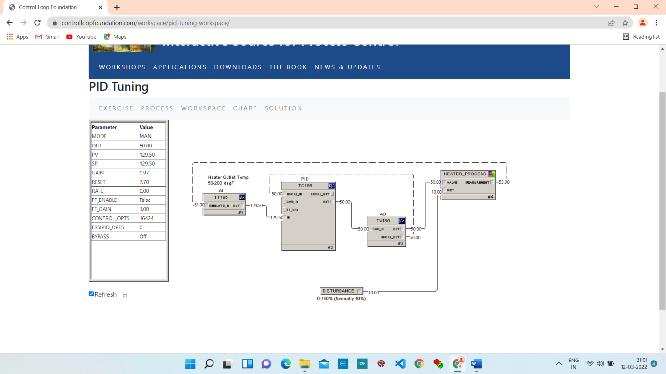

**Increase the output by 10% (50 to 60)**

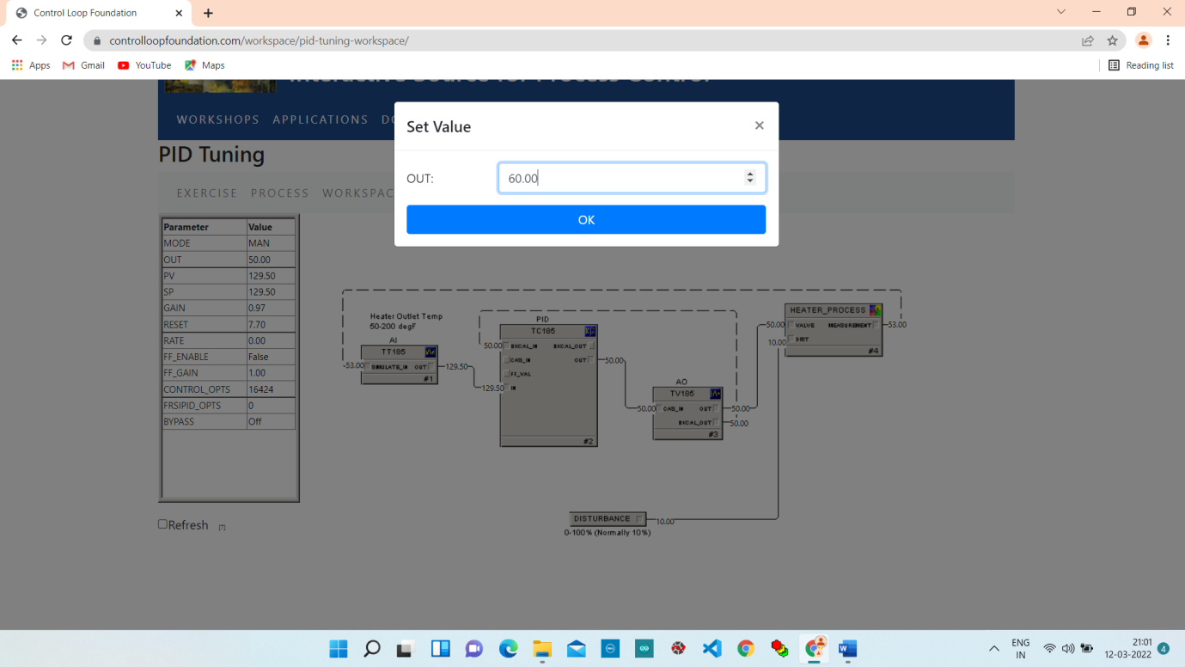

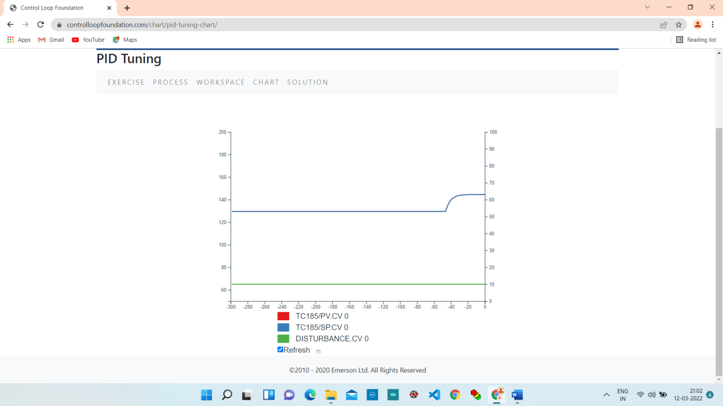

**2. Change Gain value from 0.97 to 0.1**

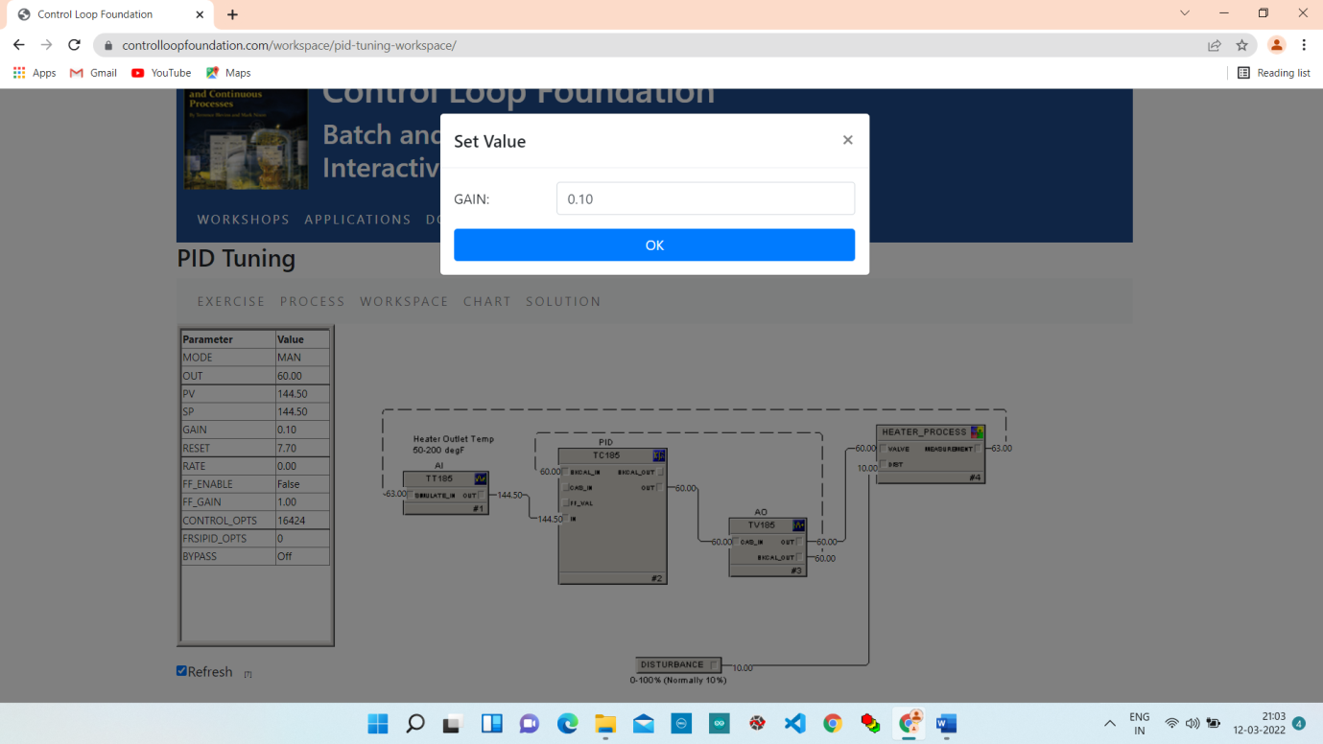

**Change the Mode from MAN to AUTO.**

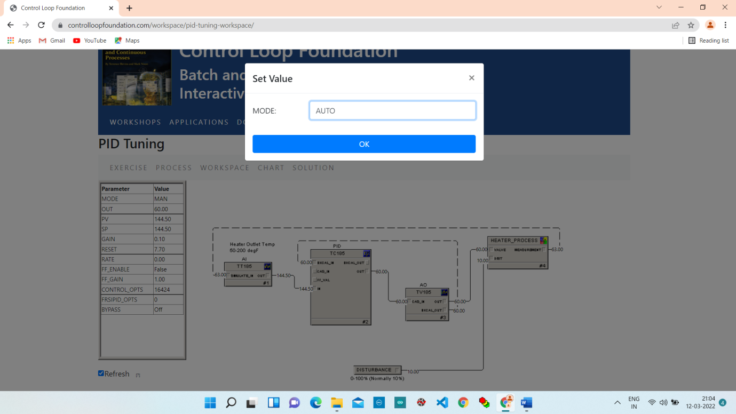

**Change the Setpoint value from 144 to 150.**

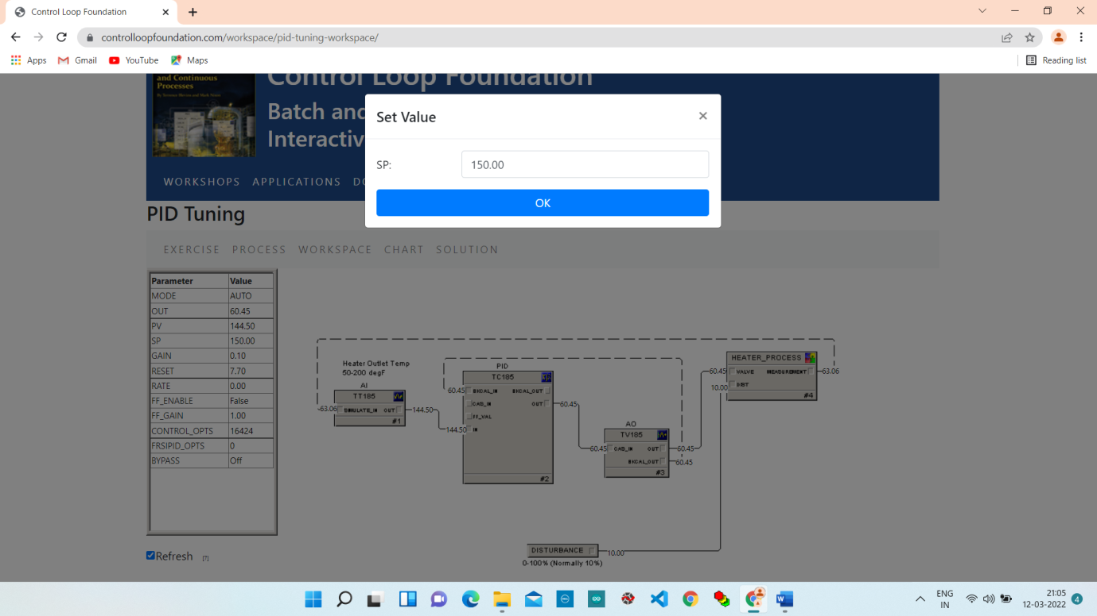

**Chart:**

Response to Setpoint change , process is very gradually change towards subpoint so in this case we can determine gain is too low.

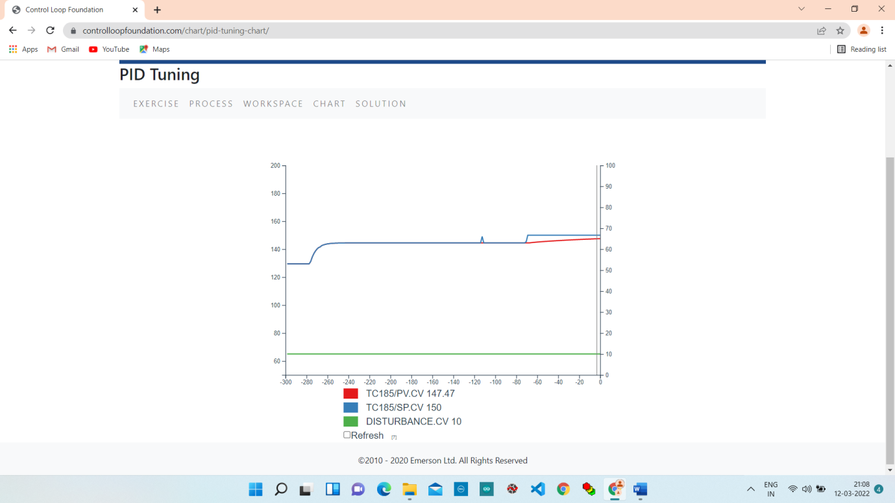

**3. Increase Gan value (0.10 to 0.5)**

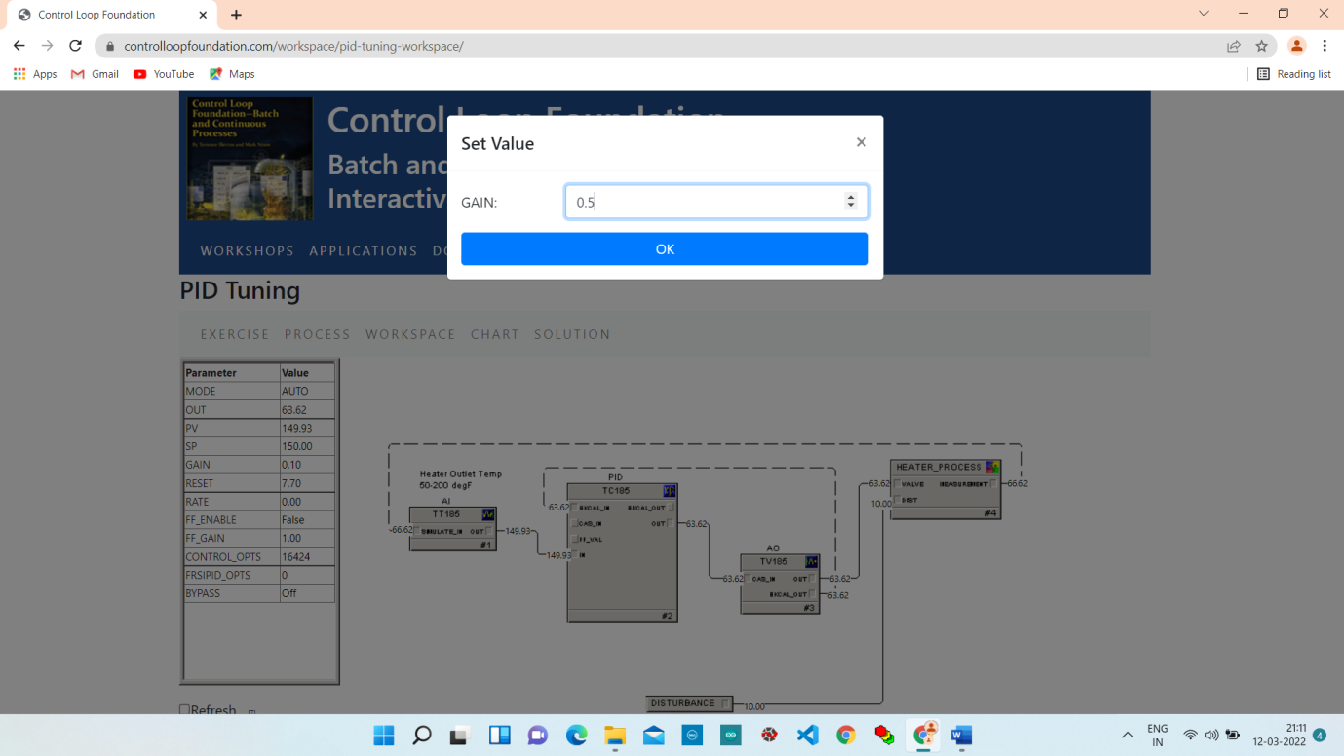

**Chart:**

Here we noticed that the response to that there is significant change or increase in rate at which the control parameter is being braught into subpoint.

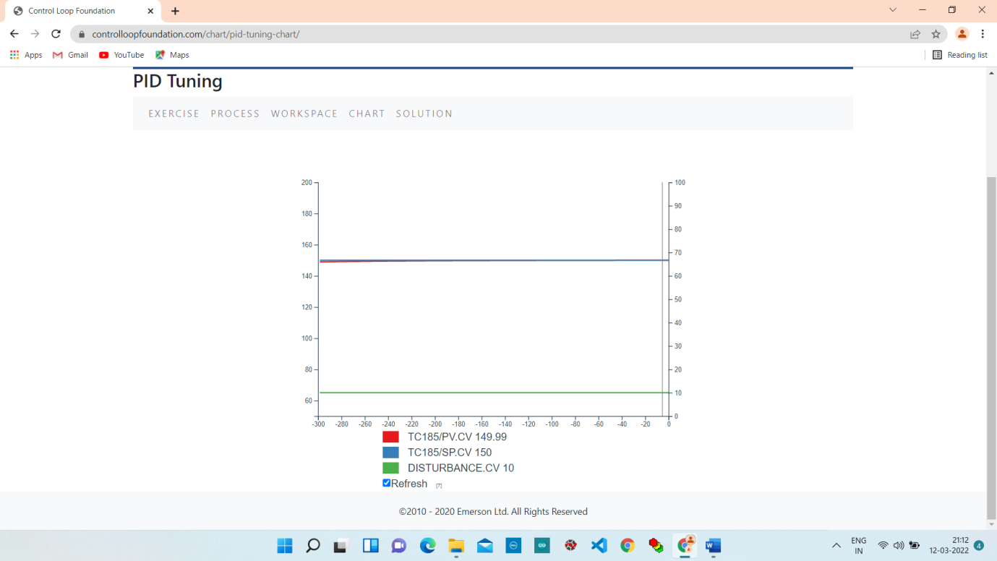

**4. Change Setpoint value (150 To 160)**

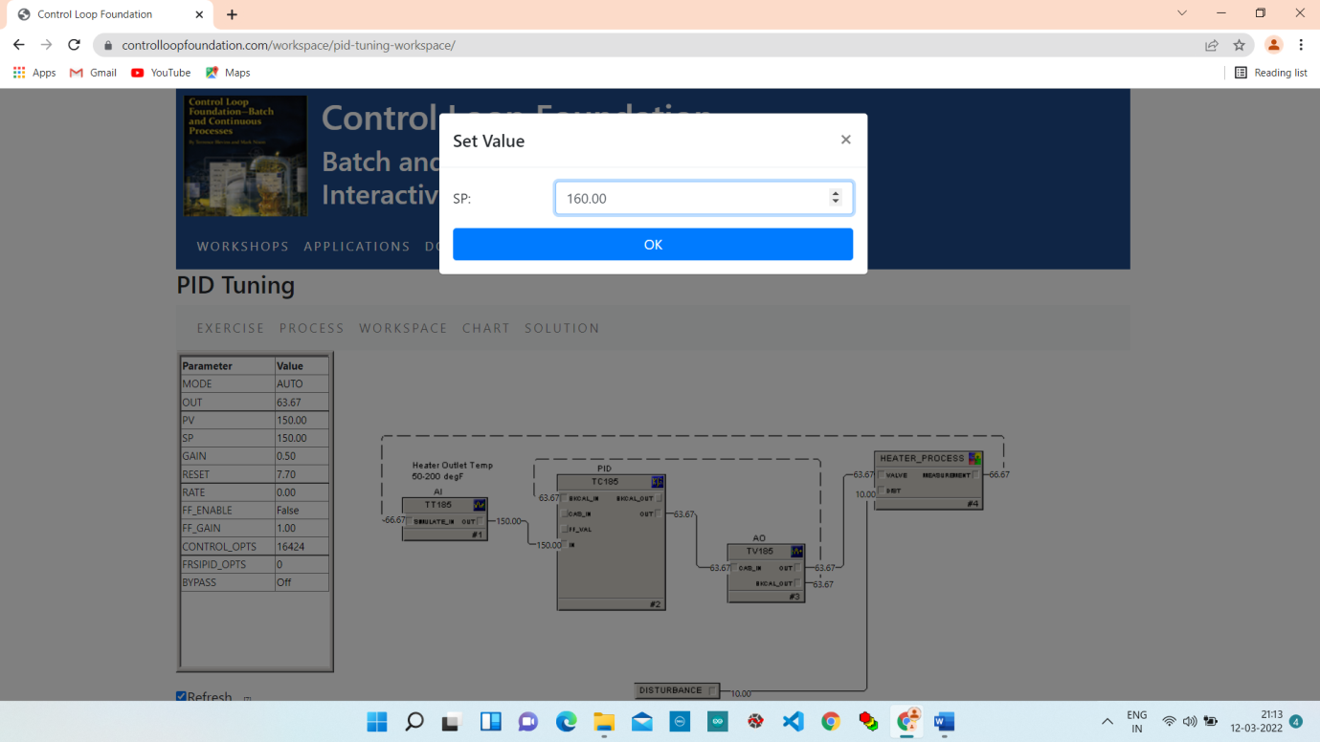

**Chart:**

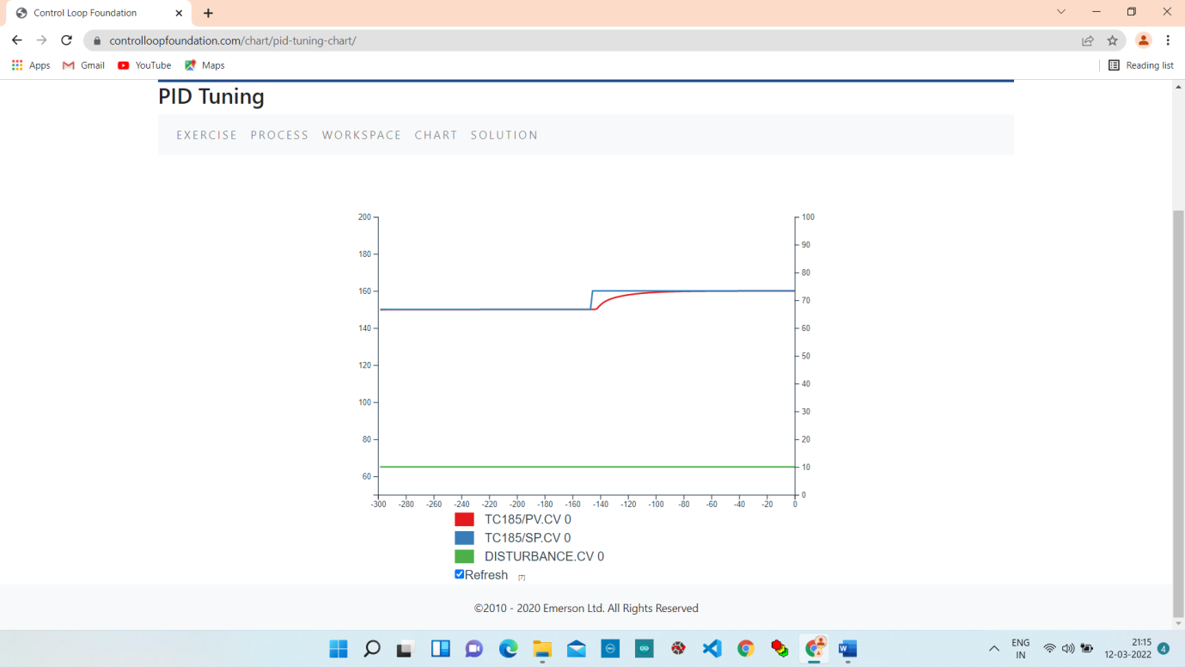

**5. Change Gain Value (0.50 To 1.00)**

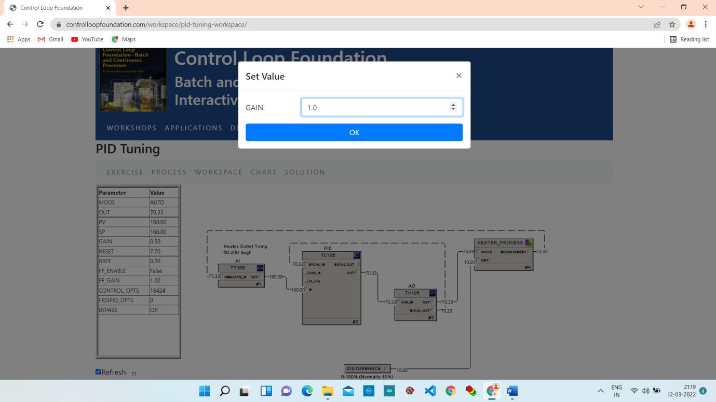

**Change Setpoint Value (160 To 150)**

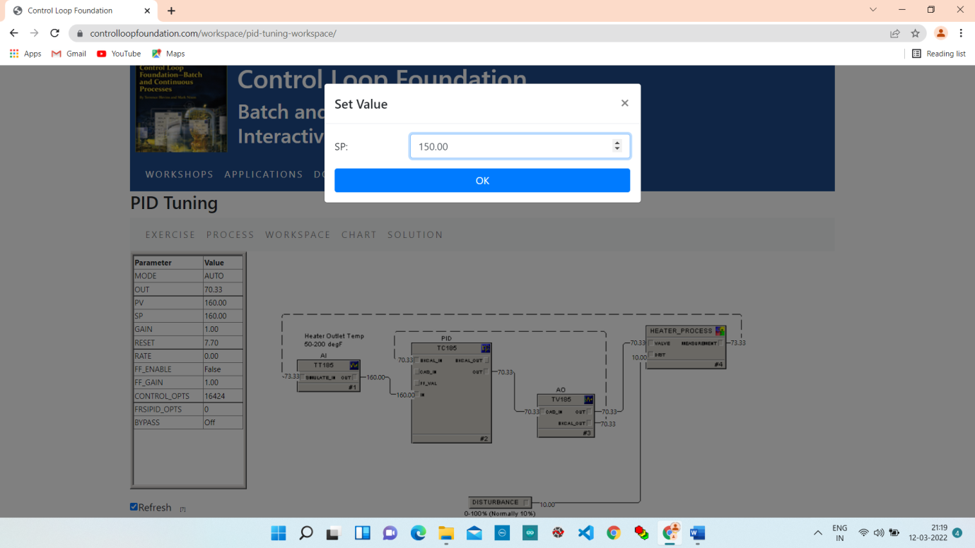

**Chart:**

Here, output we can see impact of this by looking at chart as we can see we’re coming much faster into setpoint.

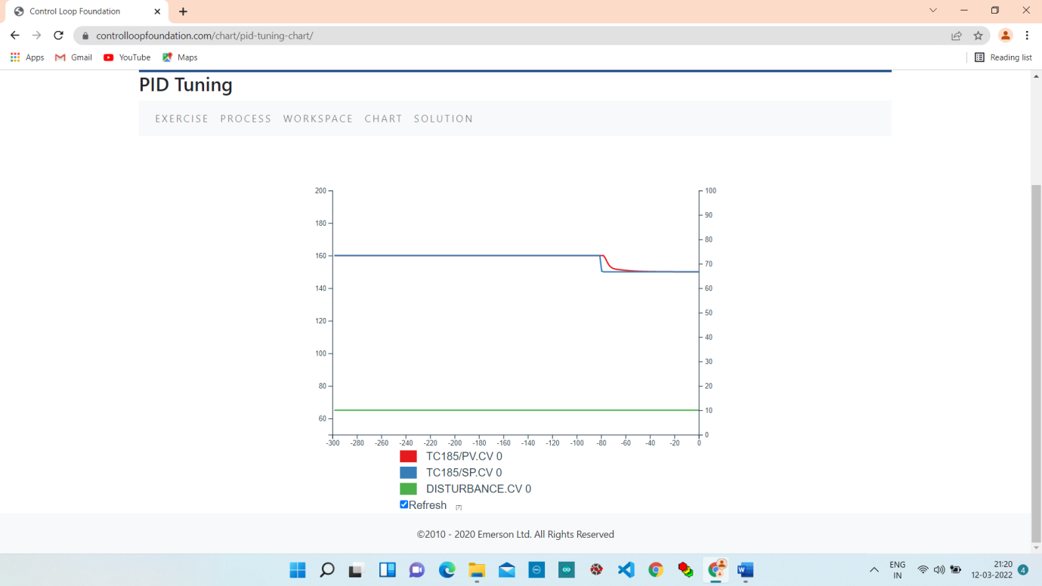

**6. Change Disturbance (10.00 To 30.00)**

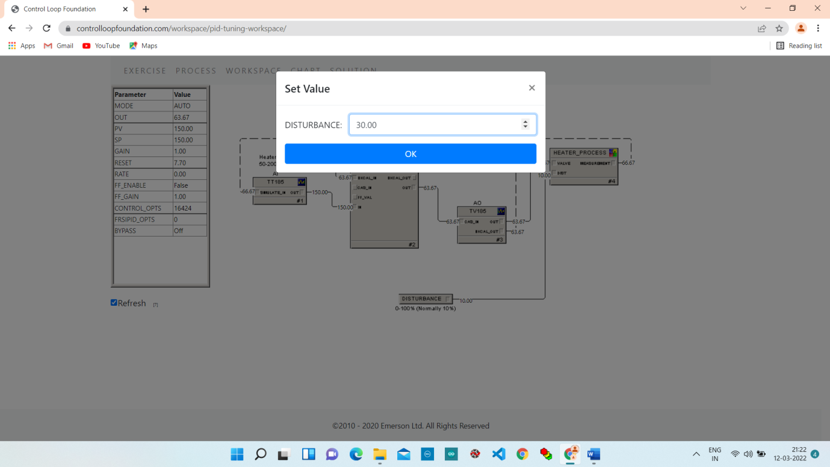

**Chart:**

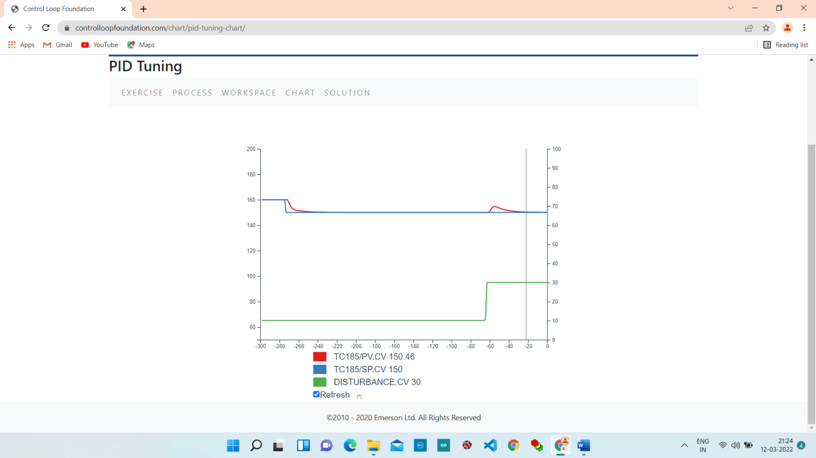

**7. Change the Gain Value (1.00 To 1.5)**

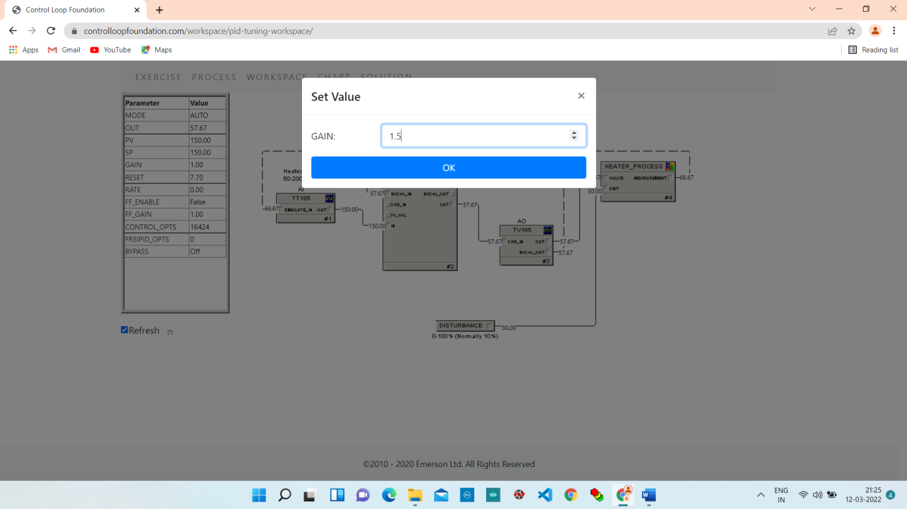

**Change Disturbance (30.00 To 10.00)**

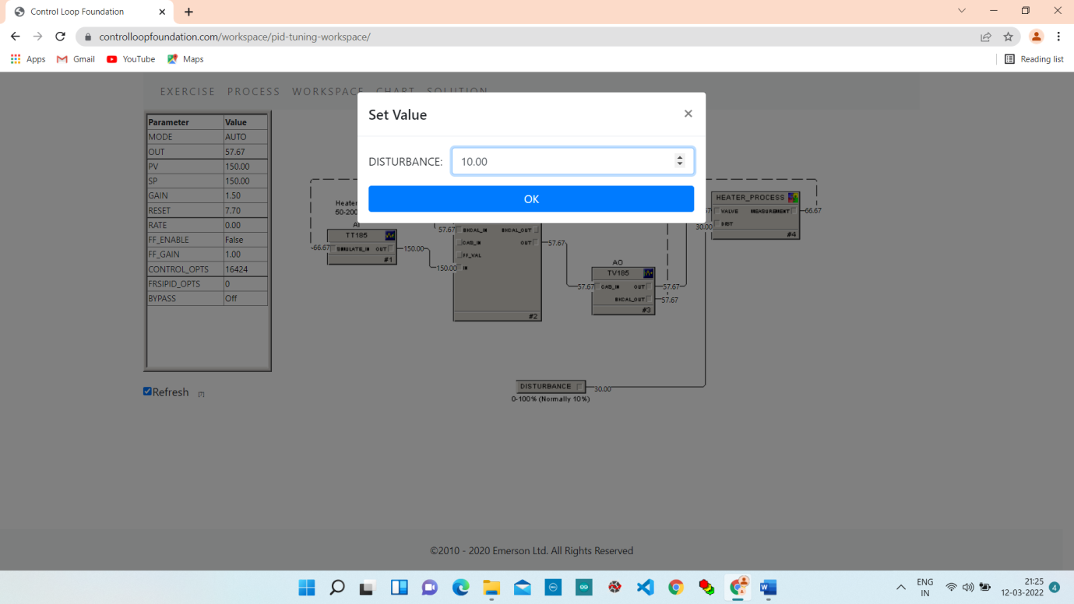

**Chart:**

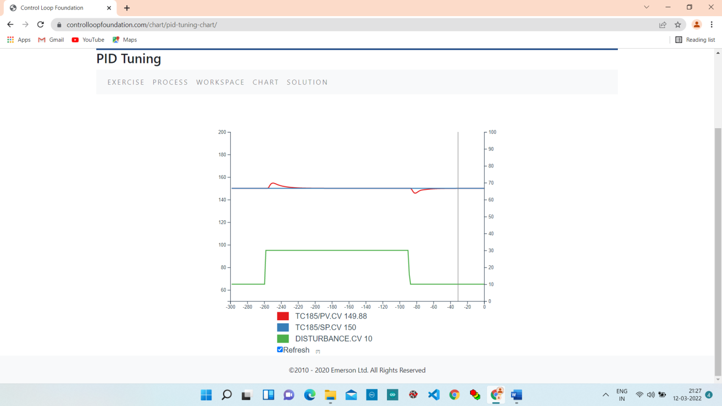

**7. Change Setpoint Value (150 To 160)**

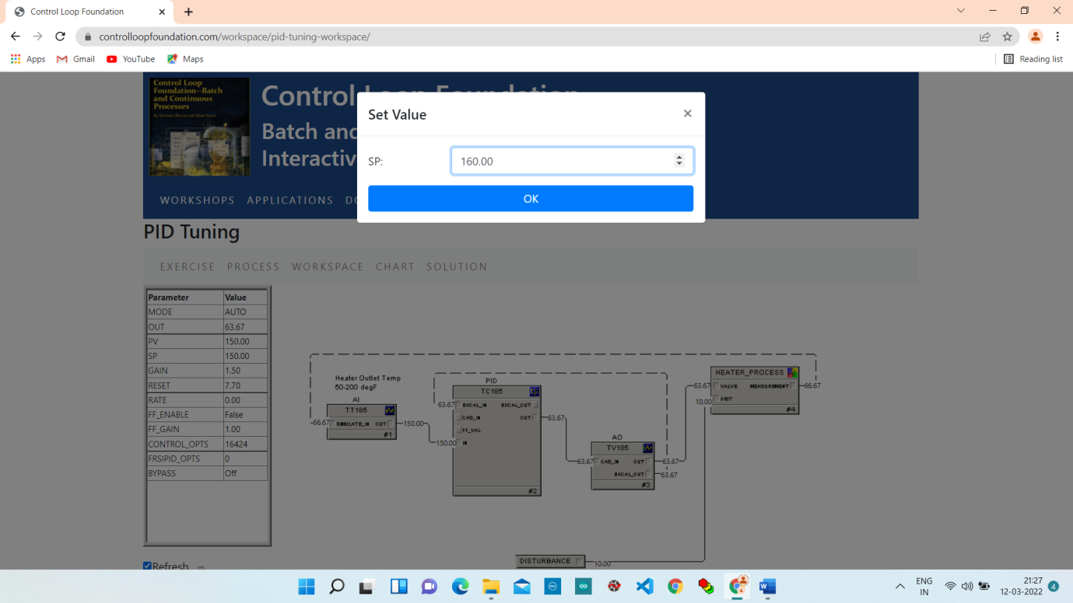

**Chart:**

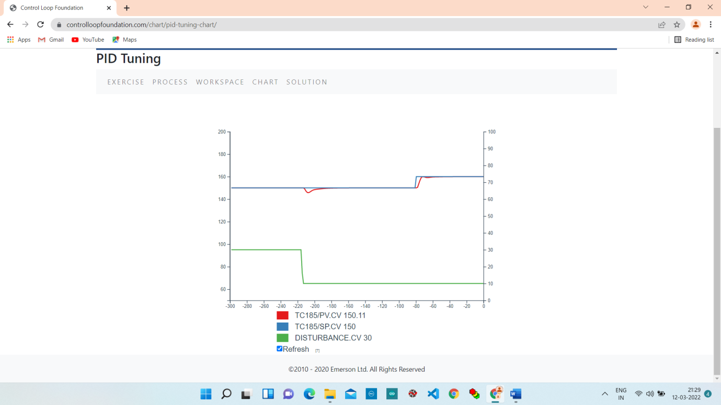

**Conclusion :**

We can observe that upon changing the setpoint the PID controller tries to bring the process variable to the desired value. Upon changing the disturbance value, the PID controller maintains the PV near the SP, hence we can conclude that PID is effective in controlling the process.